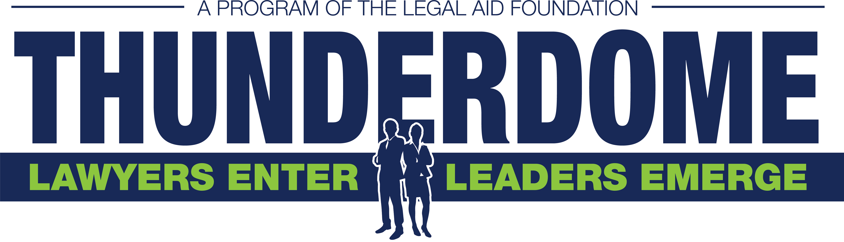

CLASS 8 PARTICIPANT APPLICATION

THUNDERDOME TALLAHASSEE PROGRAM INFORMATION
The Legal Aid Foundation of Tallahassee announces Class 8 of Thunderdome Tallahassee, a hands-on legal group training program to provide education, camaraderie, networking, leadership and recognition to a new generation of lawyers serving the community. Thunderdome Tallahassee prepares a diverse group of lawyers for trial, community service, and involvement at a leadership level. Lawyers of all ages, practice backgrounds, and experience levels are encouraged to apply.

Current and incoming 2L and 3L students are encouraged to apply. Students will be paired with a lawyer participant and mentor for the duration of the program but involvement will be limited.

For consideration for Class 8, please return a completed application by 5:00 pm Thursday, March 2, 2023 to:

Lauren Stafford, Executive Director

Legal Aid Foundation of Tallahassee

lauren@legalaidtallahassee.org

Please note the Legal Aid Foundation of Tallahassee does not have a fax.

Applications accepted by email only.

THUNDERDOME TALLAHASSEE: THE STORY

The Legal Aid Foundation of Tallahassee (LAF) estimates over 2,300 low-income families in Leon County need help in family law each year, once facing a 3-4 month wait for a volunteer lawyer. This is a major unmet need threatening home, family, and livelihood. Thunderdome Tallahassee addresses this gaping need for equal access to the law, while supporting volunteer lawyers with the best in legal education and leadership development.

The original Thunderdome concept was offered to us by clinics in Chicago and Connecticut, recommended as best practices by the ABA. Taking it to the next level, LAF and university, legal, judicial, and community leaders enhanced the model with in-depth education, mentoring, and leadership.

BENEFITS FOR PARTICIPANTS AND LAW SCHOOL STUDENTS

Participants will experience:
- Family law education, CLEs, and mentoring/coaching by some of Tallahassee’s best family law lawyers, Second Judicial Circuit Judges and Magistrates.
- Hands-on trial experience and client interaction
- Camaraderie and networking to last a lifetime
- Widespread public recognition
- The best in legal, judicial, and community speakers
- Community engagement opportunities
- Invitations to leadership roles in future Thunderdome classes

Any school will be recognized along with an associated participant, as they:
- Experience invaluable networking and referral connections
- Receive small group exposure to local judges and lawyers
- Become known as community leaders
- Are recognized widely for their service among the legal community and in the public eye

PROGRAM COMMITMENT
- Have full support from school and firm/employing agency if applicable
- Give the time necessary to complete the program and the pro bono case(s) assigned
- Maintain a personal commitment to Thunderdome Tallahassee after graduation

Thunderdome Tallahassee Class 8 runs February 2023 – August 2023. All participants commit to attend:
- Thunderdome Class Kickoff Mixer
- One Thursday night per month at FSU Law School, 5:30-7:30 pm (dinner provided) for CLE credit, case mentoring/discussion, and leadership development
- Finale Mixer
- Thunderdome Awards (January 2024)

Attorney participants handle one carefully screened and monitored pro bono family law case* at a time, with:
- The assistance of an experienced family law mentor
- The assistance of a law student
- Professional liability (legal malpractice) insurance coverage provided by LAF to its volunteers

* The time commitment for each family law case varies. Mentors are available by phone, email, and often during and after Thunderdome classes and events.

Attorney participants commit to handling assigned* cases to completion, even if a case extends beyond the duration of Class 8. In this event, Class 8 mentors will continue to assist the participant. Students are encouraged to continue to assist the participant as well.

SELECTION CRITERIA

Thunderdome Tallahassee seeks current lawyers who:
- Demonstrate leadership attributes through career/student achievement or participation in community activities
- Represent personal and professional diversity among law students in Florida
- Have a drive for social change and community leadership
- Seek a deeper sense of camaraderie with legal professionals
- Desire to share personal/professional resources/expertise
- Value hands-on learning and personal and professional development

2023 TENTATIVE CLASS SCHEDULE

(All regular classes are 5:30 - 7:30 pm, casual dinner provided)
- Mentor Mixer – Date and Venue TBD
- Class 1 – March 9th, 5:30 – 7:30 pm at the College of Law Research Center
- Class 2 – April 13th
- Class 3 – May 11th
- Class 4 – June 8th
- Roundtable Lunch - TBD
- Class 5 – July 13th
- Class 6 – August 10th
- Class 7 – Final Class – September 14th – Final Class
- Finale Mixer - TBD
- Thunderdome Awards Luncheon – January 2024

REQUIREMENTS
- Attend all classes and events (contact the Executive Director to discuss any unavoidable conflicts).
- Student participants must contact their attorney participant and mentor regarding their current assigned pro bono case at least once each month.
- Attorney participants must contact their pro bono client at minimum once each month, and as the case requires. Student participants must contact the client as attorney participant and mentor require.
- Commit to continue to volunteer with a Legal Aid organization after the training is complete.

APPLICATION PROCESS
- Participant applications are due by February 3, 2023

THUNDERDOME TALLAHASSEE CLASS 8 PARTICIPANT APPLICATION

PARTICIPANT INFORMATION
Name:
Law School:
Law School Year:
Legal focus, if applicable:
Home Address:
Business Phone:
Business Email:
- List up to five community, civic, religious, political, government, social, athletic, or other activities in which you have played an active role. Do not include business/professional activities.

Organization: Assignment/Position: Responsibilities: Dates (from/to)

- How much time each month do you commit to volunteer work and/or pro bono service?

- What does pro bono legal services mean to you?

- List the kinds of volunteer activities in which you would like to become active in the future.

- If you have not had the time or interest to become actively involved, what conditions have changed that now enable you to seek involvement in the community?

PARTICIPANT COMMITMENT

I understand the requirements of THUNDERDOME TALLAHASSEE CLASS 8 as outlined in the Program Information. I will devote the time and resources necessary to complete the class program and become an active member of the alumni group after graduation. I understand the above commitments and agree to be bound by them in signing this application.

______________________________________________________________________________

Applicant Signature Date

COMMITMENT BY SCHOOL, FIRM OR EMPLOYING AGENCY

This application has the approval of this organization and the candidate has our full support, which includes the time required to participate in the class program and to handle the accompanying pro bono case(s) assigned by Thunderdome Tallahassee.

_________________________ _____________

Signature Date

Printed Name and Title

______________________________________

Company/Organization

